FINAL PRODUCT AND BUSINESS CASE
Team Name: FoundersSuite Product Name: FoundersSuite

1. Final Product Description
FoundersSuite is a B2B end-user discovery marketplace that connects early-stage founders with domain-specific target users for structured validation conversations. The platform transforms what is currently a fragmented, time-consuming process (cold LinkedIn outreach, asking friends and family, or expensive research platforms) into a centralized, frictionless system that delivers real signals from real people.

Founders currently face two broken paths when seeking product validation: cold outreach that yields a 5–10% response rate and drains hours of founder time, or feedback from personal networks that is systematically biased toward encouragement. The Mom Test (Fitzpatrick, 2013) documents how warm-network validation structurally overstates product interest. In 100% of the founders we interviewed, they had relied on personal networks for validation despite recognizing its unreliability. FoundersSuite eliminates both failure modes.

What the User Can Accomplish
- Book a structured discovery conversation with a domain-matched end user (a clinician, hospital professional, SaaS buyer, or industry practitioner) without any cold outreach or research panel fees
- Receive an AI-generated insight summary after each conversation round, surfacing pain point patterns, willingness-to-pay signals, and feature priorities in investor-ready format
- Access a community discussion feed where end users share domain-specific problems and experiences, generating continuous signal beyond one-on-one conversations
- Build a validated evidence base before fundraising or launch — grounded in Guest, Bunce & Johnson (2006), who found thematic saturation occurs within 12 in-depth interviews, with core themes emerging as early as 6.

How It Works - Three Steps
- AI-Powered Matching: A Singular Value Decomposition (SVD) recommendation algorithm surfaces end-user suggestions based on problem domain, lived experience, and discovery needs: not demographics. The model weights domain expertise and contextual fit differently per industry (e.g., a MedTech founder needs clinicians with regulatory awareness, not just healthcare workers).
- Tinder-Style Review: Founders accept, reject, or further evaluate each recommended user. Matched users receive invites to a discovery conversation. Founders retain full visibility into tester profiles and credibility signals, preserving autonomy in the validation process.
- AI Feedback Summary: After each discovery round, founders receive AI-powered summaries and insights synthesized from conversation content and available community discussion threads. Post-interview nudges flag biased or leading questions for founder improvement.

Beachhead Domain - MedTech B2B: FoundersSuite launches in MedTech B2B specifically because 90% of MedTech startups fail, 34% due to lack of product-market fit, and MedTech end users (clinicians, hospital professionals) are the hardest B2B professionals to reach through conventional channels. Establishing a stronghold in the hardest vertical makes expansion into adjacent B2B domains (vehicle tech, B2B SaaS, edtech) structurally easier — the sourcing infrastructure and org partnerships transfer directly.

2. Market Demand

The Problem - Validated by Data
42%  of startup failures  built something no one wanted | 225%  IP overestimation  before product-market fit | $130B  wasted annually  2–5 years per failed startup

Source: Startup Genome, CB Insights

42% of startup failures are attributed to building something no one wanted. Founders overestimate the value of their IP before product-market fit by 225%, translating to 2–5 years of wasted effort and $130B in capital destroyed annually. FoundersSuite intervenes at the earliest and most cost-effective point in the startup journey.
Our own primary research confirms the demand: 100% of the 20 founders we interviewed had experienced biased market validation. 65% rated their current customer discovery tools as unreliable, flagging qualifications and feedback quality as top concerns. 85% explicitly stated they would use FoundersSuite, with 25% of those being MedTech founders - directly validating the beachhead.

Target Market
- Target Customer - Early-Stage Founders: Small, resource-constrained teams of 2-8 people building MVPs who need structured, evaluative insights from their end-users before fundraising or launch. These founders need investor-ready validation reports and cannot afford expensive research panels.
- Target User 1 - End-Users: People experiencing significant pain points that drive cause for action - clinicians, hospital professionals, SaaS buyers, industry practitioners. Motivated to contribute insights toward products that solve their real problems.
- Target User 2 - Domain Experts: Experts with substantial domain knowledge willing to volunteer time to help early-stage founders, often through innovation committee structures (e.g., ANA Innovation Committees at hospital networks).

Market Sizing
- TAM - $115.99B: 150M startups globally, at $773.28/customer/year. Represents the total revenue potential from all startups globally.
- SAM - $678.6M: 1.17M US startups with teams under 10 (75% of 1.56M US startups), at $579.96/customer/year. The segment with the most acute validation problem and least access to structured research tools.
- SOM - $39.1M: 67,500 US MedTech startups with teams under 10 (75% of 90K US MedTech startups), at $579.96/customer/year. Our immediate beachhead. The MedTech industry is projected to reach $719.20B by 2028 at a 4.73% CAGR (PMC), meaning the pool of MedTech founders requiring validation grows continuously.

Sources: Startup Genome, U.S. Census Bureau, MedTech industry data, PMC.

Competitive Landscape
Key competitors include BetaTesting.com (subscription/credits model, no AI matching), Applause (contract basis, enterprise-focused, no early-stage support), and Testlio (custom quote, QA-oriented). None are designed for the early-stage founder; all use demographic filtering rather than contextual, experience-based matching; and none offer pay-per-conversation pricing.

Feature | FoundersSuite | BetaTesting.com | Applause | Testlio
Pricing Model | $45/conversation (flat) | Subscription / Credits | Contract Basis | Custom Quote
Early-Stage Founder Friendly | ✓ Yes | ✕ No | ✕ No | ✕ No
AI-Powered Matching + Insight Summary | ✓ Full AI matching + reports | ✕ No AI matching | ✕ No AI insights | ✕ QA-focused only
Matched by Lived Experience | ✓ Yes | ✕ No | ✕ No | ✕ No
Pay Per Conversation | ✓ Yes | ✕ No | ✕ No | ✕ No
Designed for Pre-MVP Validation | ✓ Core use case | ✕ No | ✕ No | ✕ No

Competitive Edge: FoundersSuite is the only platform purpose-built for pre-MVP discovery. Our SVD-based matching algorithm surfaces end users based on lived experience and problem context - not demographics - ensuring the 5-12 conversations a founder needs (Guest et al., 2006) are with the right people. Competitors cannot replicate this because our model depends on proprietary data, continuous feedback loops, and domain-specific tuning that compounds over time.

Revenue Model & Unit Economics
Pricing: Flat $45 connection fee per confirmed B2B end-user discovery conversation. No subscription, no commission, no recurring charge. The founder pays once, the conversation happens, and they receive an AI insight summary.
Pricing Rationale: LinkedIn cold outreach to a qualified B2B professional yields a 5–10% response rate; the DIY cost to find, vet, and schedule one relevant contact runs $60–100 at a $20/hour opportunity cost. FoundersSuite undercuts the DIY alternative by more than half. Market rates for B2B remote research sessions run $80–200/hr (User Interviews Incentives Report, 2022, n≈20,000 studies).

Key unit economics:
$1,800  Annual Rev/Founder  40 convos × $45 AOV | $180  CAC  Referral/partnership channel | $5,400  Founder LTV  $1,800 × 36 months | 30x  LTV/CAC Ratio  Investor threshold: 3x | ~1 mo  CAC Payback  Fastest quartile

Source: GTM 80/20 (2026); User Interviews Incentives Report (2022); YC/Carta data; Teresa Torres, Continuous Discovery Habits (2021).

Margin & Scaling: Gross margin improves from 18.7% in Year 1 to 69.8% by Year 3 as org partnerships replace cash incentives as the primary end-user sourcing channel. Revenue scales across three levers: (1) growing active founders on the platform (150 → 600 → 3,000 across Years 1–3), (2) increasing conversation frequency per founder as the platform becomes embedded in their workflow, and (3) expanding domain partnerships that progressively reduce sourcing costs.
- Year 1: $243K revenue - 150 MedTech founders via UCI NVC + ANA Innovation Committee partnerships, 5,400 conversations
- Year 2: $1.08M revenue - 600 founders across quarterly B2B domain expansion (B2B SaaS, edtech, vehicle tech) + iOS/Android launch
- Year 3: $6.48M revenue - 3,000 founders via VC fund partnerships deployed as portfolio value-add tool
VC Flywheel: In Year 3, founders use FoundersSuite validation metrics in investor pitches. When investors act on those signals, their decisions become a credibility signal for the platform, circularly reinforcing FoundersSuite's reliability - a self-reinforcing growth loop.

3. User Interface

Describe the user interface. Provide specific graphics or detailed descriptions of key user interfaces.
Founders Suite features a two-sided React JS web interface. The landing page presents visitors with a clear choice to join as a founder or tester, alongside platform features, onboarding steps, and calls to action.
Founders sign up and create a company profile capturing their logo, company name, description, industry tags, product demo, and team stats, and what they are looking for in a tester including time commitment and feedback style. They then access a dashboard to define their target user requirements, review their AI-matched tester feed filtered by new, high match, and ready to connect, and review AI-generated post-interview summary reports containing key findings, actionable next steps, and nudges flagging biased or leading questions.
Testers sign up and create a profile capturing their domain background, lived experience, skills, expertise, testing preferences including platform type and testing type, hourly rate, availability, timezone, and industry interests. They then interact with a Tinder-style match feed displaying ranked company cards showing match percentage, what the company is seeking, compensation, and urgency, with options to accept, view full details, or reject. Testers can also browse and contribute to a community discussion feed within their domain space.
The interface was iteratively refined through direct user walkthroughs, with accessibility criteria considered throughout the design process.
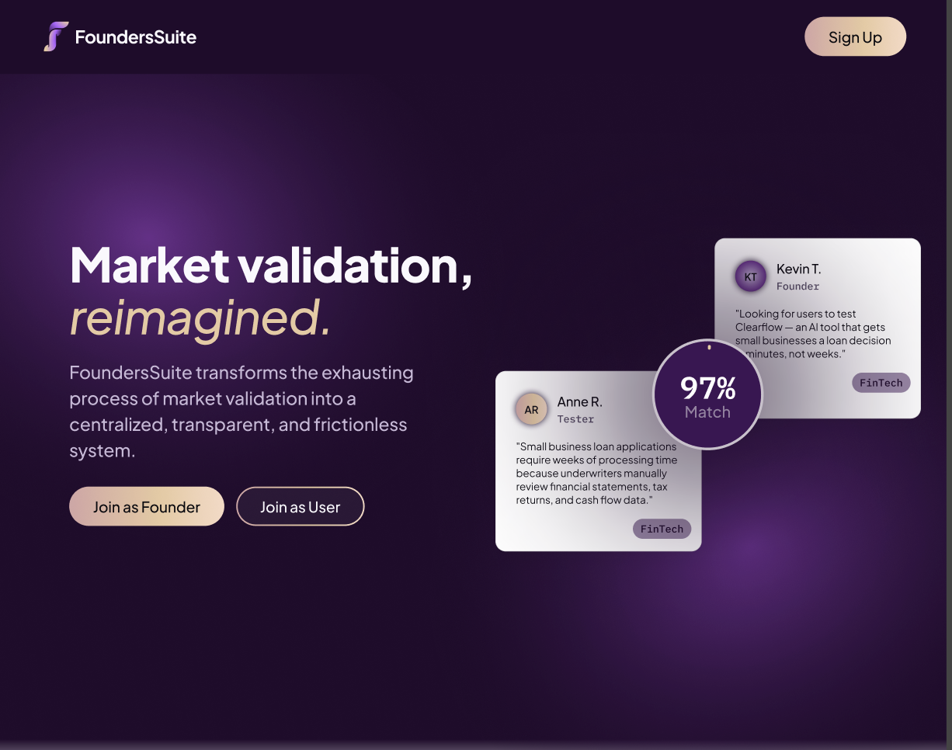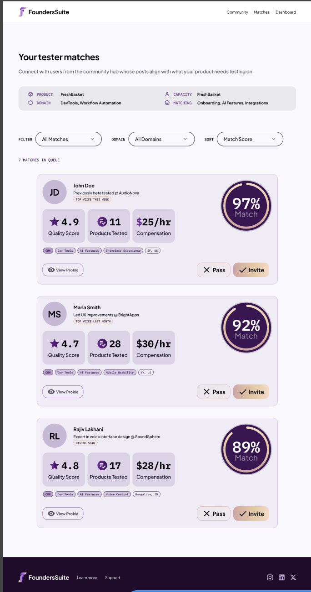
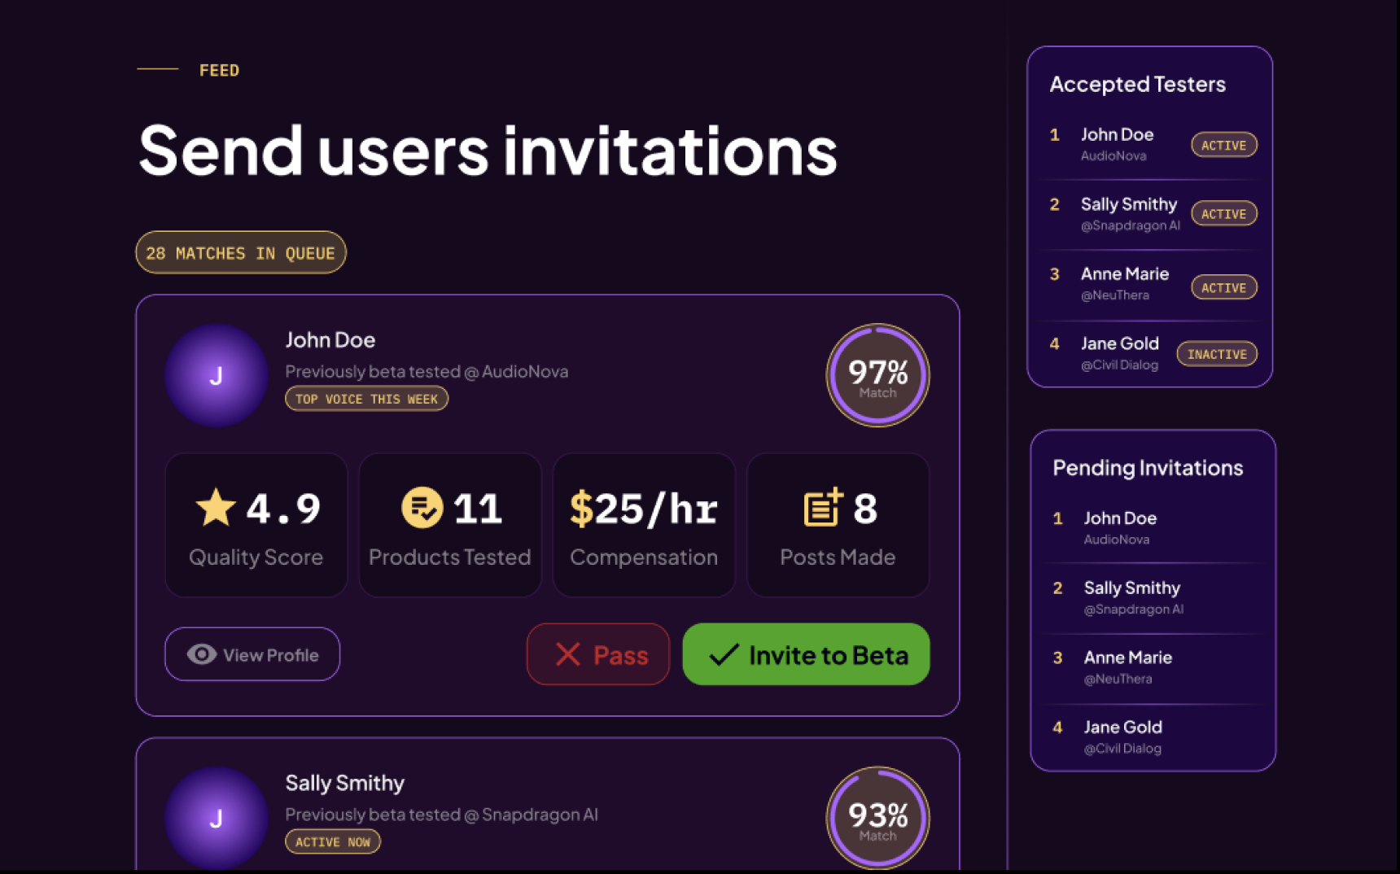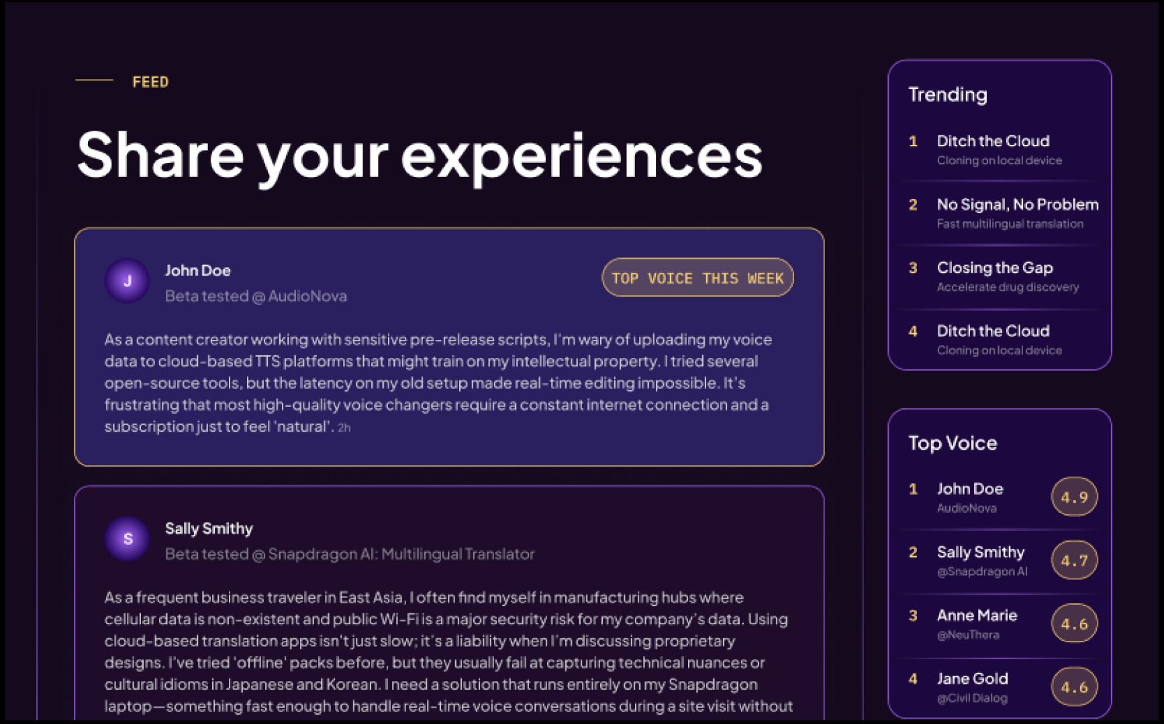

4. Prototype Development

Summarize the product development process.
The team conducted extensive ideation and competitive research across existing products to identify where AI adds the most meaningful value, focusing on domain-matched and personal lived experience tester recommendations combined with generic filter criteria, and AI-driven insight generation as the core differentiators.

Software & Hardware Requirements
A full-stack application built entirely in-house, comprising a React JS frontend, SQL backend, SVD-based recommendation algorithm with domain-specific tuning, a fine-tuned LLM for natural language processing, and LangChain AI agents for automated insight extraction and bias-detection nudges on founder interviews. Founders Suite is a software only platform and no specialized hardware was developed or required.

What specific products (developed by other manufacturers) does this product utilize?
No third-party manufactured products were used. The stack is built entirely on open-source frameworks and public research.

How were the modules and the entire product tested?

The prototype was validated through UI walkthroughs with real users, with accessibility for color blindness factored into the evaluation. The AI model was seeded with public Kaggle datasets for initial training.

What did your prototype demonstrate? What important things did you learn about improving the prototype before taking it to users and/or trying to produce it at a competitive price?

The prototype demonstrated a functional two-sided platform where founders can describe their product and target user requirements, and testers can discover and evaluate matching opportunities through an AI-driven recommendation engine. Competitive research and initial user walkthroughs validated that matching founders with testers based on domain-specific background and personal lived experience is a stronger approach than the broad demographic filtering used by existing platforms. Initial UI feedback highlighted the importance of accessibility and interface clarity for both founder and tester onboarding flows, which the team has incorporated into ongoing iterations of the prototype.

6. Additional Comments

Go-To-Market - 4-Stage Strategy
- Stage 1 - Credibility (0–6 months): Direct outreach to MedTech beachhead (hospitals, MedTech startups). Acquire end-user supply through ANA Innovation Committee partnerships. Leverage student status and professor collaborations to create educational content around founder validation.
- Stage 2 - Awareness (6–12 months): Expand social presence, launch iOS and Android, target early-stage founders with short-form content, amplify via Google and LinkedIn search ads, post on ProductHunt, begin quarterly expansion across B2B domains.
- Stage 3 - Community (12–18 months): Sponsor hackathons, attend entrepreneurship conferences, launch edu growth hack for student founders, advertise community feed with successful discovery stories as proof of concept.
- Stage 4 - VC Collaboration (18–30 months): Partner with venture funds to deploy FoundersSuite across portfolio companies as a value-add resource. Founders use validation metrics in pitches; VC investment decisions become credibility signals that reinforce platform reliability - a self-reinforcing flywheel.

Why FoundersSuite Wins
The validation gap - the space between a promising idea and the resources to prove it - disproportionately kills startups that lack expensive networks or research budgets. FoundersSuite democratizes access to real signal. At $45 per conversation with a domain-matched end user and AI-generated investor-ready insights, we are the only platform that is simultaneously affordable for early-stage founders, high-quality enough to generate real signal, and purpose-built for the discovery conversation use case. That combination does not exist anywhere else in the market.

Appendix: Team Information
Team Name: FoundersSuite
Product Name: FoundersSuite

Full Name | Student ID | UCI Email | Major(s) | Minor | Est. Grad Year | % Prize | Signature
Varshini Vijay | 22508415 | varshinv@uci.edu | Computer Science |  | 2027 | 30% | VV
Mihika Guntur | 75367376 | mguntur@uci.edu | Business Administration & Informatics |  | 2026 | 20% | MG
Sanjay Marathe | 56348936 | maraths1@uci.edu | Computer Science |  | 2028 | 10% | SM
Braden Stanislav Ransom | 61084780 | bsransom@uci.edu | Informatics |  | 2026 | 10% | BSR
Samra Zoya Rahman | 43001123 | samrar@uci.edu | Biomedical Engineering |  | 2027 | 20% | SZR
Aarav Garg | 14561617 | aaravg3@uci.edu | Computer Science |  | 2027 | 10% | AG

